Chapter 9, Solution 41.

Find v(t) in the RLC circuit of Fig. 9.48.

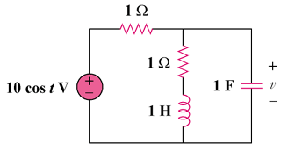

Figure 9.48
For Prob. 9.41.

Solution

,

,
Thus,
v(t) = 6.325cos(t – 18.43) V

